Design Challenge A:

What immediately comes to mind when thinking of a piece of technology that was important to me in the past was my Nintendo DS. A slimline, portable device that could be used anywhere which held the potential of endless hours of entertainment, the Nintendo DS will forever be a huge part of my childhood and I am hit with a huge wave of nostalgia as this design challenge begs me to reminisce of the past. To answer how the device ‘fits’ is an interesting concept, as what would the needs of a 12/13-year-old adolescent really consist of? Put simply the need to be entertained was highly valued at that age when your next biggest concern was an A4 side of homework to complete. Moreover however, I think it also facilitated another need to be fit in amongst peers at a time where the popularity of the device was at it’s peak. Seeing it advertised combined with the fact that your friends all had one only heightened the ‘need’ to possess one as I suppose a feeling of isolation can associated with not having one. Additionally, I think it ‘stuck’ so effectively due to its capabilities. Its portability made any long car journey pass by with ease as well as its function to connect with other users who are in the vicinity only added to its addictive qualities.

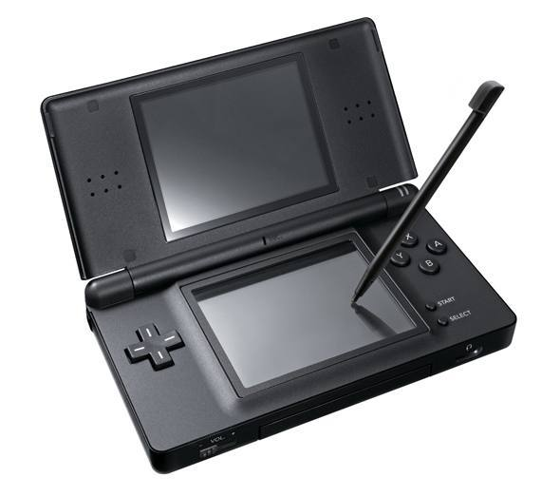I think what naturally led me to steering away from the DS was maturity and eventually wanting the next big console which for me was the PS3. As I grew older me, and my friends would spend countless hours after school and on the weekends together online which would replace the DS. In reference to more recently, the device no longer fits with me as my interests as I become older have changed and additionally my free time, something that I have less and less of nowadays is filled with other hobbies, spending time with friends and families or ultimately procrastinating.

Words: 328